Abstract

The Online Darshan Management System is a console-based platform designed to facilitate seamless and efficient management of darshan (religious visitation) services at temples and other religious institutions. It leverages modern technologies to enhance the overall darshan experience for devotees while streamlining the operational processes for the religious authorities.

The system offers several key features that cater to the needs of both devotees and temple administrators. For devotees, it provides an easy-to-use online portal or mobile application that allows them to schedule darshan appointments, check the availability of slots, and receive real-time updates about darshan timings and any special events or festivals. This eliminates the need for devotees to wait in long queues and ensures a more organized and convenient darshan experience.

**Page 1**



Contents

|  |  |  |
| --- | --- | --- |
| Chapter | Contents | pageNo. |
| 01. | Introduction | 5 |
| 02. | System Requirement Specification  2.1 Overview | 6 |
| 03. | User Of the system 3.1 Admin  3.2 Users  3.3Devotee  3.4Output Details | 6 |
| 6 |
| 7 |
| 7 |
| 04. | Software Requirement and Hardware Requirement   * 1. Software Requirements   2. Hardware Requirements (Minimum): | 8 |
| 8 |



**Page 3**

List of Figures

|  |  |  |
| --- | --- | --- |
| **Fig No.** | **TITLE** | **PAGE NO.** |
| 01. | E-R Diagram | 9 |
| 02. | Data Flow Diagram   * 1. Admin DFD   2. Users DFD   3. Devotee DFD | 10  11  12 |
|  |  |  |



**Page 4**

# Introduction

The Online Darshan Management System is a console-based application designed to

streamline and enhance the process of seeking darshan (spiritual visits) at religious

places of worship such as temples, mosques, churches, gurdwaras, and other sacred

sites. This project aims to leverage modern technology to create a more efficient and organized approach for devotees to participate in religious rituals, ceremonies, and

receive blessings from their deities.

Traditionally, the process of seeking darshan involves long waiting queues, crowded premises, and uncertain wait times. This can be time-consuming, physically demanding,

and may even discourage some people from visiting places of worship altogether. The

Online Darshan Management System seeks to alleviate these challenges and offer an improved and seamless experience for devotees.

### Features of Online Darshan Management System:

1. **Online Darshan Booking**: The system allows users to book their darshan slot online in advance. They can select the preferred date, time, and type of

darshan (regular, VIP, etc.) based on availability.

1. **Real-time Queue Status**: Devotees can check the real-time status of the

darshan queue through the system. This feature enables them to plan their visit accordingly and reduces the uncertainty of wait times.

1. **VIP/Special Darshan**: For special occasions or VIP visitors, the system can provide a separate queue management system, ensuring that they receive priority access.
2. **E-Payment Integration**: The platform will have secure payment gateways to enable online donations, offering contributions, and payment for VIP darshan slots.
3. **Live Darshan Streaming:** For those who are unable to visit the religious site physically, the system can offer live streaming of darshan, allowing devotees to experience the spiritual atmosphere from the comfort of their homes.
4. **Feedback and Reviews**: Users can provide feedback and reviews about their darshan experience, enabling the authorities to improve the overall process and facilities.
5. **Reporting and Analytics**: The system will generate reports and analytics on the number of visitors, peak hours, popular darshan timings, etc. This data can assist in efficient resource allocation and planning for future events.



* **Benefits of the Online Darshan Management System:**

1. **Enhanced User Experience**: Devotees can enjoy a smoother, well-organized darshan process, reducing waiting times and physical strain.
2. **Improved Queue Management**: The system optimizes the flow of visitors, ensuring a more orderly and peaceful environment at religious sites.
3. **Increased Transparency**: Real-time queue updates and availability information contribute to greater transparency in the darshan process.
4. **Better Resource Planning**: Analyzing data from the system helps religious authorities to plan resources effectively and cater to the varying demands of visitors.
5. **Global Access**: Live streaming of darshan extends accessibility to devotees worldwide, transcending geographical boundaries.

**System Requirement Specification**

# Overview

The Online Darshan Management System is a comprehensive console-based application designed to facilitate and streamline the process of seeking darshan (spiritual visits)

at various religious places of worship. The system leverages modern technology to enhance the overall darshan experience for devotees and optimize the management

of visitors at religious sites. It aims to make the darshan process more convenient, organized, and accessible to a wider audience.

# User Of the system

1. Admin
2. User
3. Devotee

# Admin :

This module is operated by the user who is the Admin of temples. The Admin should view the online bookings for online darshan whose bookings are done by Users. The module provides various services view appointments, delete the users and the records.

# User:

User Register itself. After Registering by users user logins as a user and books the Appointments and time slots for online Darshan. Also View the all Appointments registered for online Darshan and Cancels and updates the booking of users.

# Devotee:

User Register the Devotee names, date and time slots are required for online darshan.

### Output Details:

**Home Page:**

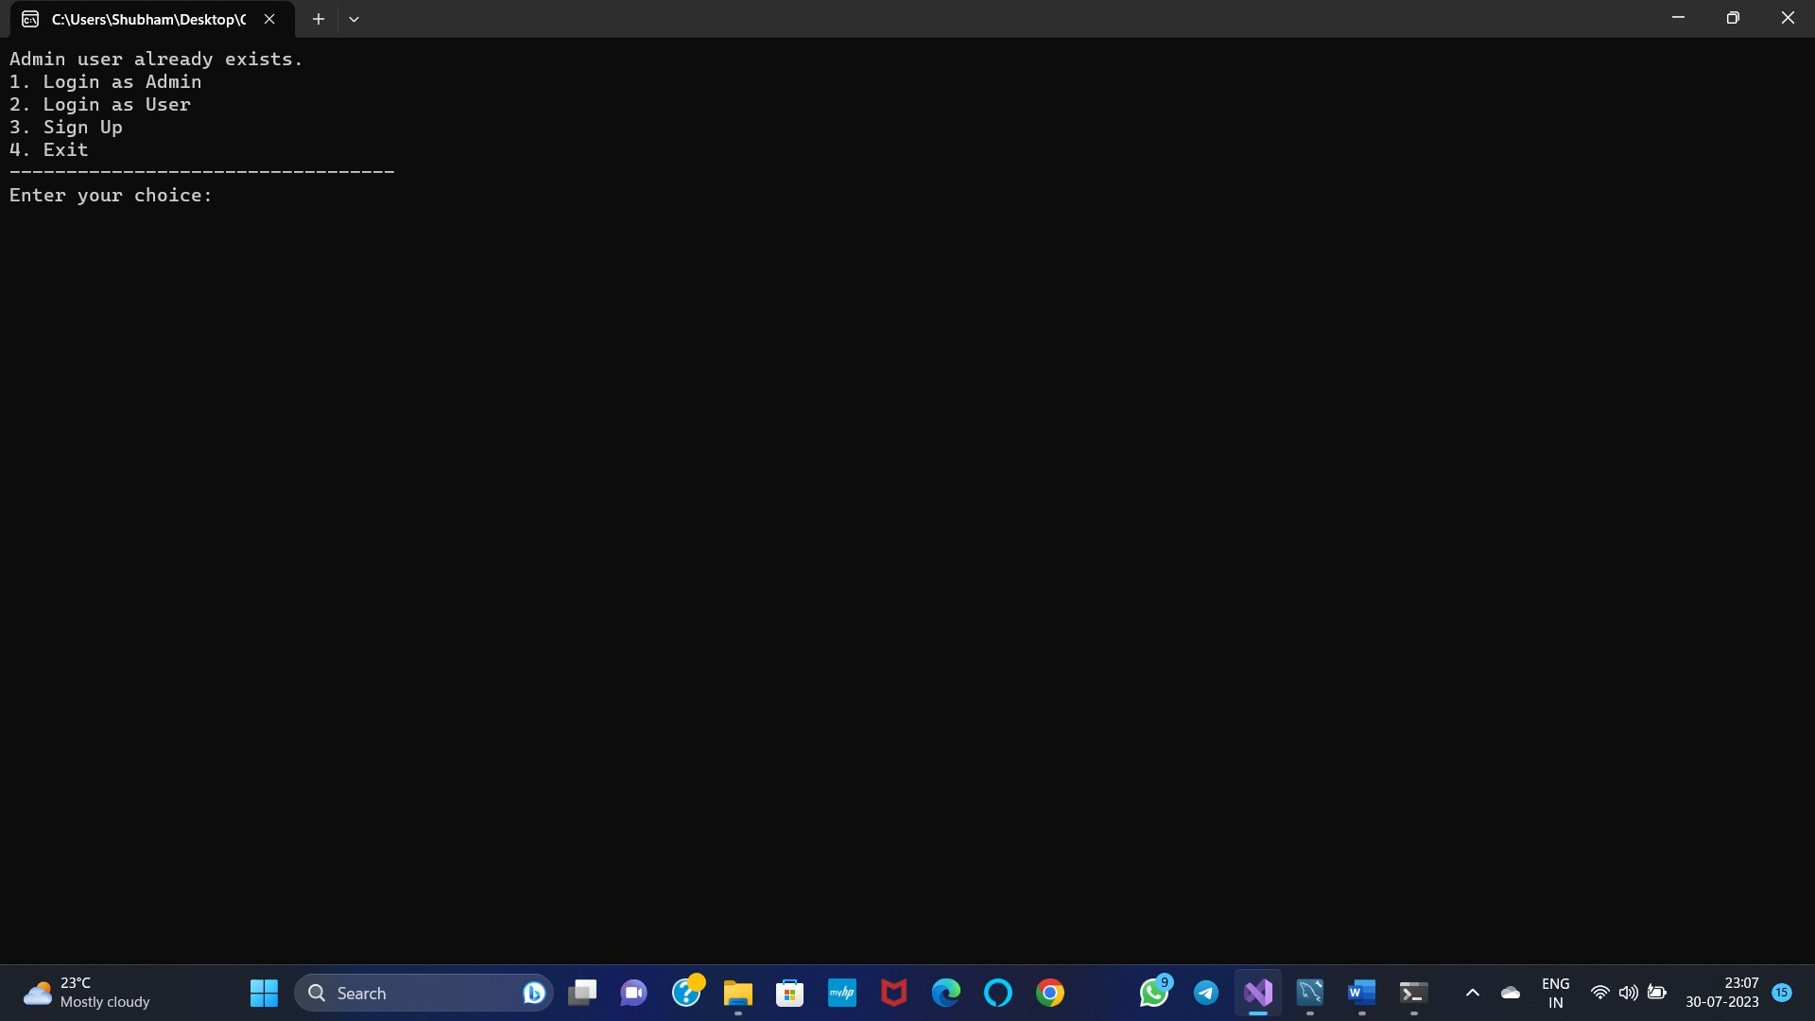

**Admin Login Page:**

The Super Login Page Contains Authority of view Appointments & Delete Users.

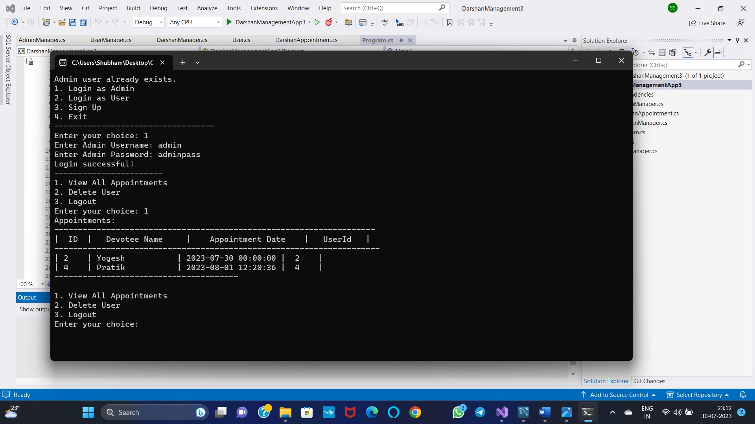

**Login as User:**

**Page 7**

l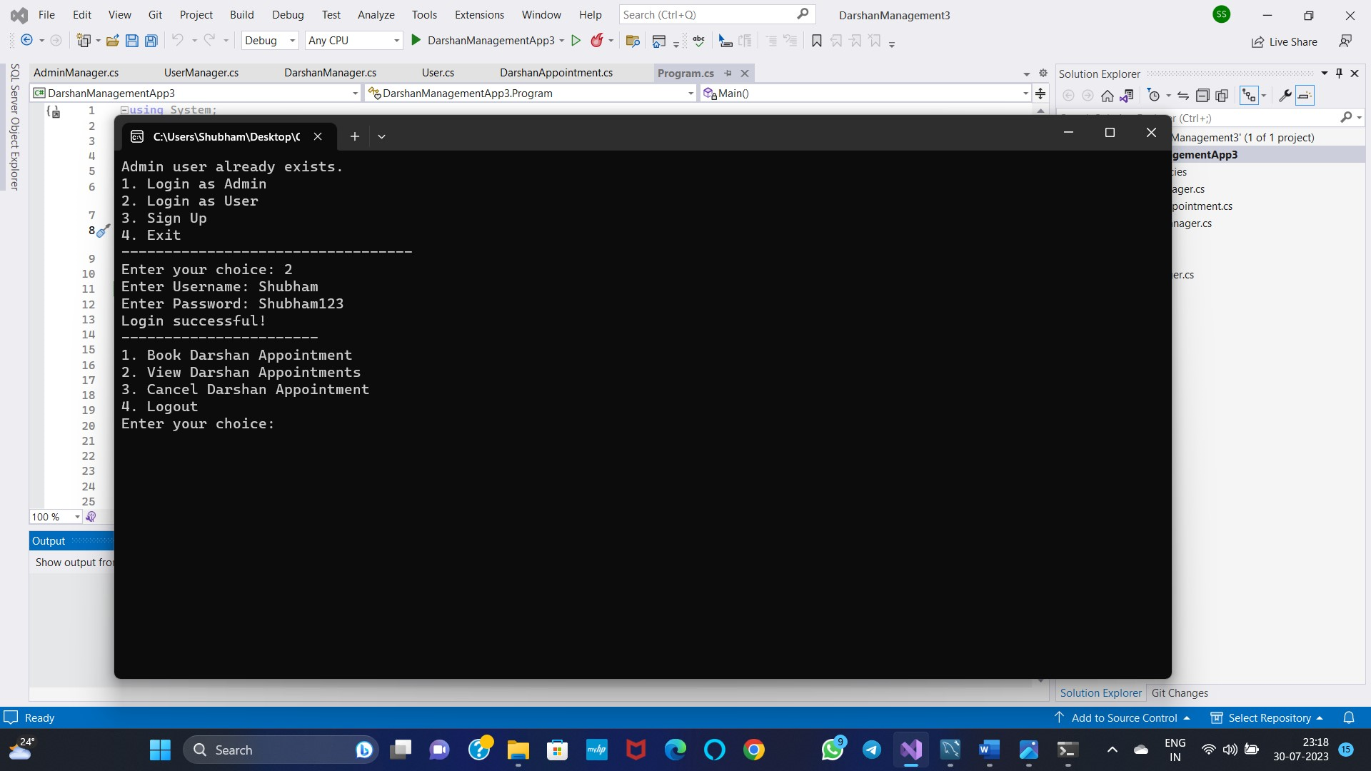

**Booking and View Appointment as a User:**

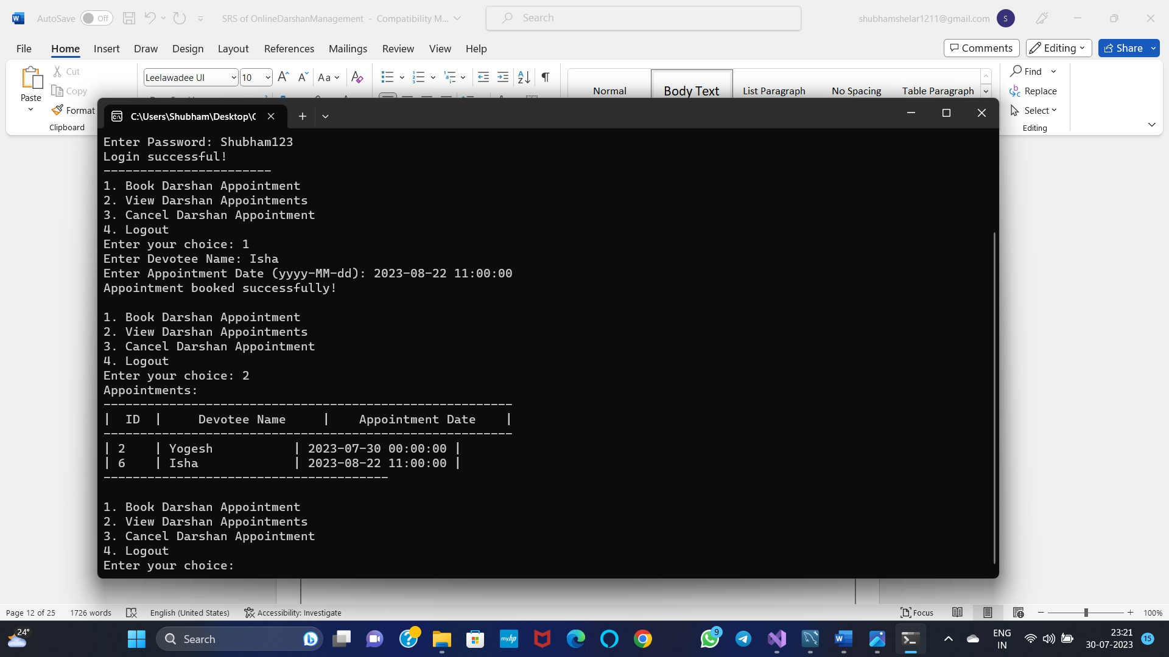

**Cancel Appointment as User:**

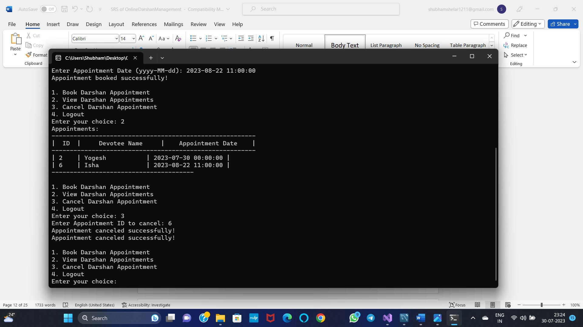

**Sign Up for User:**

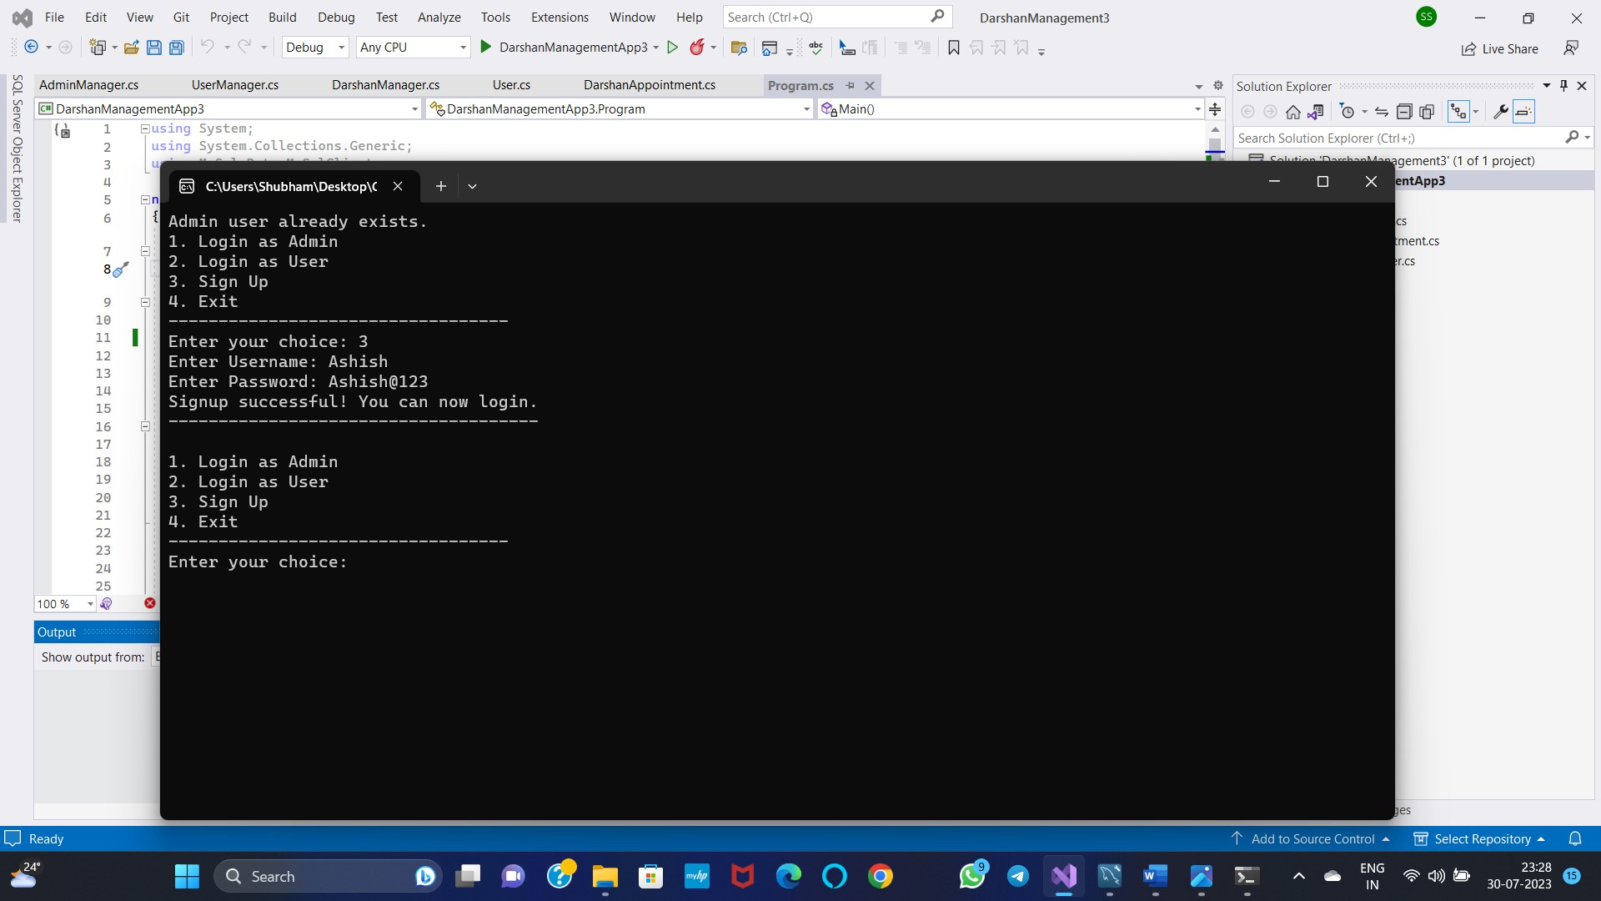

**View All Appointments and Delete Users By Admin:**

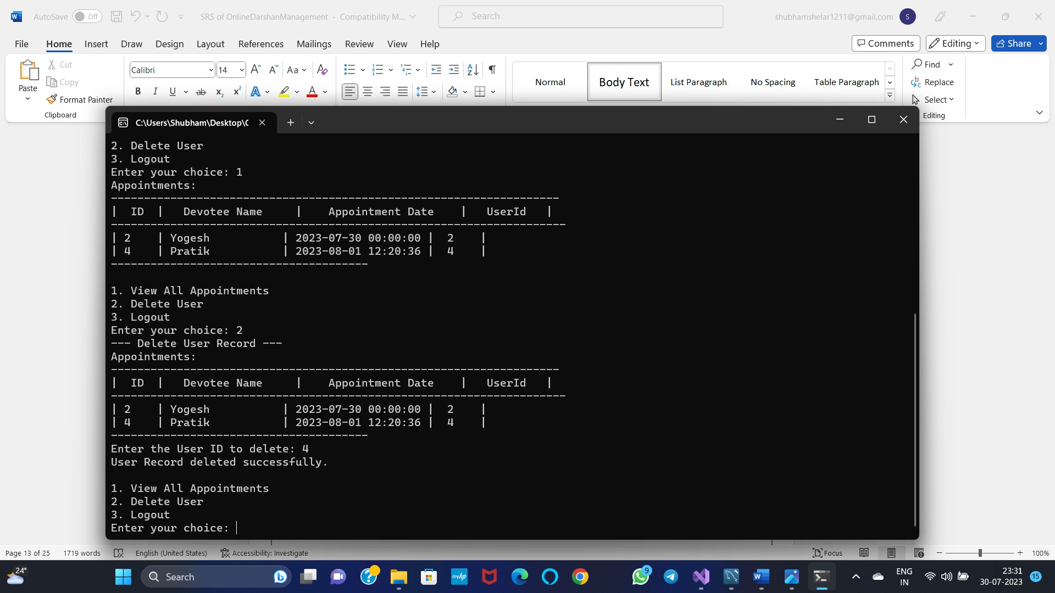

**Sign up Validation For Username has already exists:**

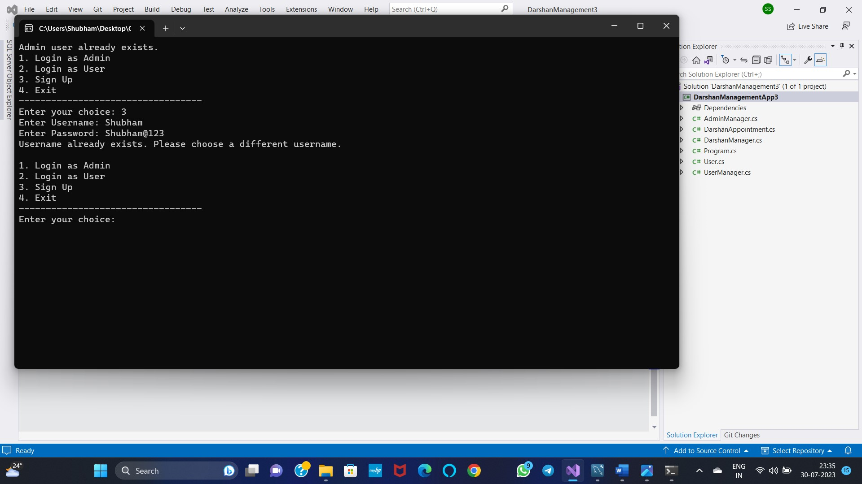

**Update the appointments:**

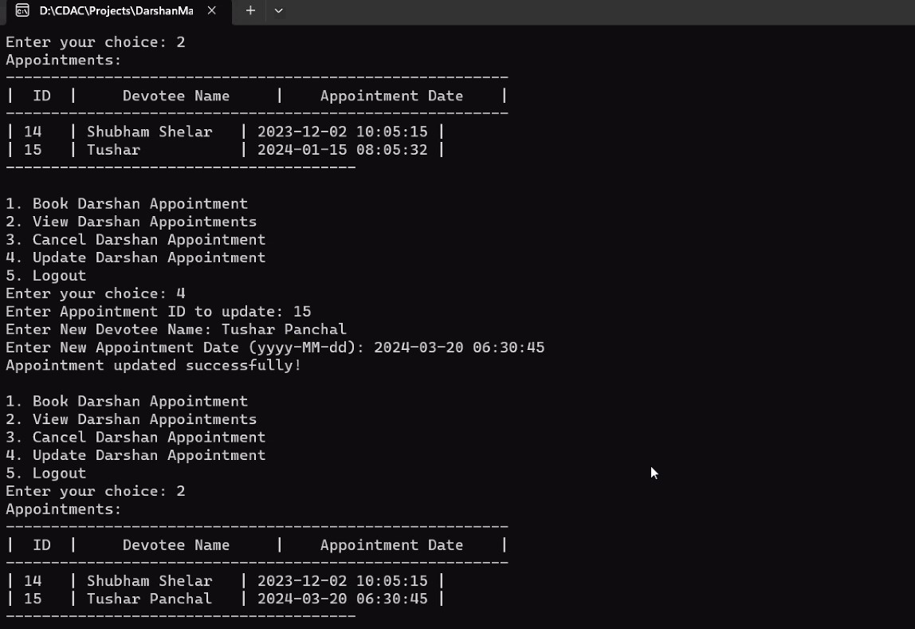

**Contact Us:**

Thank you for choosing the Online Darshan Management System. We value your feedback, queries, and suggestions. Please feel free to reach out to us through any of the following channels:

**Customer Support:**

For any assistance or support related to our platform, darshan bookings, or payment transactions, our dedicated customer support team is available to help you. You can contact them through:

**Email:** support@darshanmanagementsystem.com

**Phone:** [+XX-XXX-XXXXXXX] (Please provide your country code when dialing)

**Technical Support:**

If you encounter any technical issues while using our website or mobile application, our technical support team is ready to assist you. Reach out to them via:

**Email:** techsupport@darshanmanagementsystem.com

**Phone:** [+XX-XXX-XXXXXXX] (Please provide your country code when dialing)

Partnerships and Collaborations:

For potential partnerships, collaborations, or business inquiries, our team is eager to explore new opportunities. Get in touch with us at:

**About Us:**

1.Umair Waseem

2.Shubham Shelar

3.Raviraj Patil

At Online Darshan Management System, we are dedicated to revolutionizing the way devotees experience and participate in religious darshan. Our platform harnesses the power of modern technology to create a seamless and enriching darshan experience, making it easier for devotees to connect with their spiritual roots while ensuring efficient and organized temple management.

**Our Mission:**

Our mission is to bridge the gap between technology and spirituality, empowering devotees with a user-friendly and accessible platform to schedule their darshan appointments conveniently. We strive to enhance the sacred journey of every devotee, making it a smooth and memorable experience, whether they are visiting a temple nearby or a revered destination thousands of miles away.

**Our Services:**

**Easy Darshan Booking**: With just a few clicks, devotees can schedule their darshan appointments in advance, eliminating the need for long waiting lines and ensuring a hassle-free visit.

**Real-time Updates**: Stay informed about darshan timings, special events, festivals, and any changes in the schedule through real-time notifications on our platform or mobile app.

**Special Categories**: We understand the importance of catering to the needs of every devotee. The system allows for the allocation of specific timeframes for the elderly, differently-abled, and other special categories, ensuring everyone's comfort and inclusivity.

**Secure and Transparent Transactions**: Our integrated online payment gateway ensures secure and cashless transactions for offerings, donations, and special rituals, providing peace of mind to devotees.

**Crowd Control and Safety**: Through our carefully designed system, we prioritize crowd control and safety, helping temple administrators manage visitor counts and ensure a serene and secure darshan environment.

**Advanced Booking System**: Plan ahead and secure your darshan slots, especially during peak seasons and significant religious occasions, by using our advanced booking feature.

**Software Requirement and Hardware Requirement**

### Software Requirements:

* + **Technology**: C#
  + **Version** : C# 3.0,.Net Core 6.0
  + **Backend Database** : MySQL 8.0
  + **IDE** : Microsoft Vs code

**Hardware Requirements (Minimum):**

* + - **Processor** :Pentium IV
    - **RAM Capacity**: 1GB
    - **Hard Disk** : 160GB



**E-R Diagram:**

An ER diagram, short for Entity-Relationship diagram, is a visual representation of the data model that depicts the logical structure of a database system. It is a widely used tool in database design and serves as a blueprint for creating and understanding the relationships between various entities within the database.

The main components of an ER diagram include:

**Entities**: Entities represent real-world objects or concepts that have distinguishable characteristics. For example, in a university database, entities could be "Student," "Course," "Faculty," etc. Each entity is depicted as a rectangular box in the diagram.

**Attributes**: Attributes are the properties or characteristics of entities. They describe the information that can be associated with an entity. For instance, a "User" entity might have attributes like "Appointment ID," "Name," "Datetime," etc. Attributes are typically depicted as ovals connected to their respective entities.

**Relationships**: Relationships define how entities are related to each other. They describe the associations between two or more entities. A relationship can be one-to-one, one-to-many, or many-to-many. Relationship lines connect the entities involved and have a meaningful verb phrase label that explains the connection, such as "enrolls in," "works for," "attends," etc.

**Primary Key**: A primary key is a unique identifier for each entity instance in a database table. It is used to distinguish between different records of the same entity. In an ER diagram, the primary key is underlined.

# E-R DIAGRAM :

## SYSTEM DESIGN

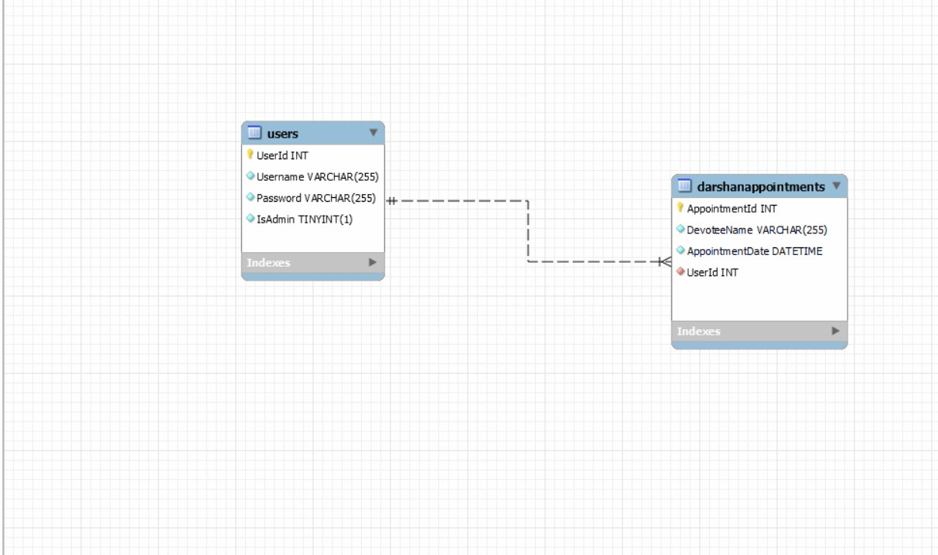



Data Flow Diagram(DFD):

# Admin DFD:



Admin



Login

Home

ViewBookings

Delete eeUsers

users

Profile

Logout

UI Displaying set

of Operation



* 1. **User DFD :**

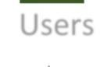

Users



login



Home

Bookings

View

Cancel

Logout

UI Displaying set of Operation





# Devotee DFD :



Devote



Login

Home

Names

Views

Bookings

dateandtime

Logout

UI Displaying set of Operation



C:\Users\Umair Waseem\Downloads\DarshanManagement3 (3)\DarshanManagement3 (2)\DarshanManagement3\DarshanManagement3\DarshanManagement3.sln

Super Admin



**13**